Lecture # 09 & 10
Course: Nanotechnology & Nanostructures
Instructor: Dr. Zohra Kayani

Book: Nanomaterials, Nanotechnologies and Design: An Introduction for Engineers by Daniel L. Schodek, Paulo Ferreira, Michael F. Ashby
Chapter: Nanometerials: Classes and Fundamental

Size Effects:
- Surface-to-Volume Ratio versus Shape
- Magic Numbers
- Surface Curvature
- Strain Confinement
- Quantum Effects
Surface-to-Volume Ratio versus Shape
Major difference between nanomaterials and larger-scale materials is that nanoscale materials have an extraordinary large surface area to volume ratio.
Almost all properties of the thin layer of atoms that lie in the surface or interface of things behave in a different way than those in the interior. Surfaces, you could say, have their own properties. At the macro scale (bulk), the fraction of atoms that lie on the surface is minuscule. On the micron scale (micro) it is still tiny. But approach the nanoscale and it takes off. This inverted the surface area to volume ratio for nanomaterials and its effects on nanomaterials properties is a key feature of nanoscience and nanotechnology.

For these reasons, a nanomaterial’s shape is of great interest because various shapes will produce a distinct surface-to-volume ratios and therefore different properties.
- The surface-to-volume ratio of a sphere of radius r is given by
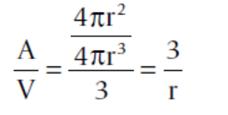
- The surface-to-volume ratio of a cylinder of radius r and height H is given by
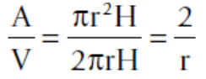
- The surface-to-volume ratio of a cube of length L is given by
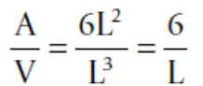
Magic Numbers
Nanoparticles have a “structural magic number”, that is, the optimum number of atoms that leads to a stable configuration while maintaining a specific structure.
If the crystal structure is known, then the number of atoms per particle can be calculated. For a decrease in particle radius, the surface to volume ratio increases. Therefore the fraction of atoms increases as the particle size goes down.
For spherical nanoparticles, the number of surface and bulk atoms is given as:
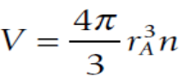 , 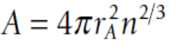
where V is the volume of the nanoparticle, A is the surface area of the nanoparticle, r_{A} is the atomic radius, and n is the number of atoms. On this basis, the fraction of atoms F_{A} (=A/V) on the surface of a spherical nanoparticle can be given by
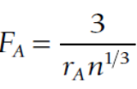
In addition to the shape of the particle, we have to take into consideration the crystal structure. For just an illustration, we assume a nanoparticle with a face-centered cubic (FCC) structure. This crystal structure is of practical importance because nanoparticles of gold (Au), silver (Ag), nickel (Ni), aluminum (Al), copper (Cu)and platinum (Pt) exhibit such a structure. We start with the FCC crystal structure shown in Figure.
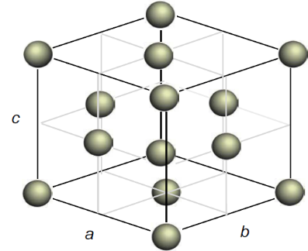
Clearly, the 14 atoms are all surface atoms. If another layer of atoms is added so that the crystal structure is maintained, a specific number of atoms must be introduced. In general, for n layers of atoms added, the total number of surface atoms can be given by
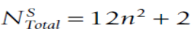
The total number of bulk (interior) atoms can be given by
Thus, above two equations relate the number of surface and bulk atoms as a function of the number of layers. These numbers are called structural magic numbers.
Equilibrium (minimum) shape of nanocrystalline particles is determined by
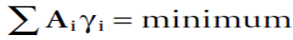
Where γi is the surface energy per unit area Ai of exposed surfaces, if edge and curvature effects are negligible.
Among the possible shapes, the smallest FCC nanoparticle that can exist is a cubo-octahedron (dual octahedron), which is a14-sided polyhedron. This nanoparticle has 12 surface atoms and one bulk atom. If additional layers of atoms are added to the cubo-octahedral nanoparticle such that the shape and crystal structure of the particle are maintained, a series of structural magic numbers can be found.
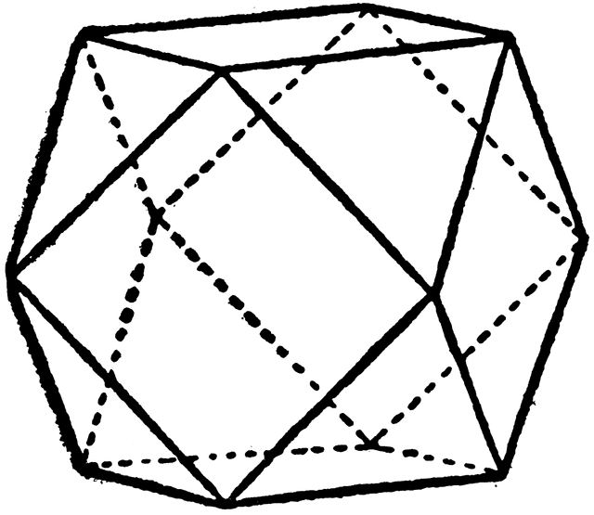
In cubo-octahedral nanoparticle, for n layers of atoms added, the total number of surface atoms can be given by
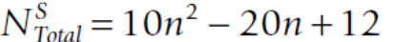
whereas the total number of bulk (interior) atoms can be given by
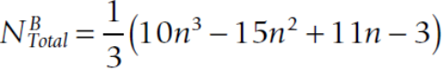
Surface Curvature
All solid materials have finite sizes. The atomic arrangement at the surface is different from that within the bulk because the surface atoms are not bonded in the direction normal to the surface plane.
Hence if the energy of each bonded atom is ε/2 (the energy is divided by 2 because each bond is shared by two atoms), then for each surface atom not bonded there is an excess internal energy of ε/2 over that of the atoms in the bulk.
In addition, surface atoms will have more freedom to move and thus higher entropy. These two conditions are the origin of the surface free energy of materials. For a pure material, the surface free energy γ can be expressed as
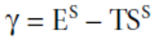
where E^{S} is the internal energy, T is the temperature, and S^{S} is the surface thermal entropy.
The geometry of the surface (specifically its local curvature) will cause a change in the system’s pressure. These pressure effects are normally called capillarity effects due to the fact that the initial studies were done in fine glass tubes called capillaries.
For the concept of surface curvature, consider the 2-D curve shown in Figure. A circle of radius r just touches the curve at point C. The radius r is called the radius of curvature at C, whereas the reciprocal of the radius is called the local curvature of the curve at C.
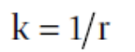
As shown in Figure, the local curvature may vary along the curve. By convention, the local curvature is defined as positive if the surface is convex and negative if concave.

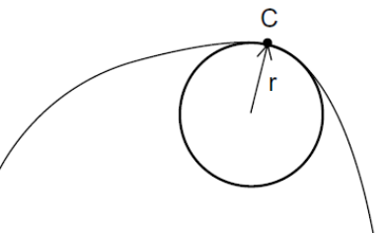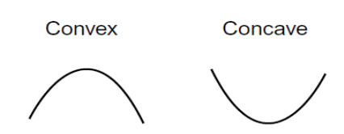
As the total energy (Gibbs free energy) of a system is affected by changes in pressure, i.e. variations in surface curvature will result in changes in the Gibbs free energy given by
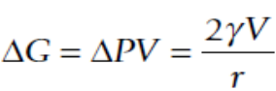
When two nanoparticles are in contact with each other, the neck region between the nanoparticles has a concave surface, which results in reduced pressure. As a consequence, atoms readily migrate from convex surfaces with positive curvature (high positive energy) to concave surfaces with negative curvature (high negative energy), leading to the coalescence of nanoparticles and elimination of the neck region. In other words, nanoparticles exhibit a high tendency to sintering, even at room temperature, due to the curvature effect.
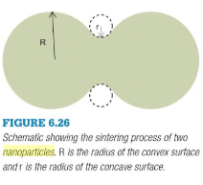
One other important physical property of a material is its lattice parameter. To understand the effects of scale on the lattice parameter, we consider the Gauss-Laplace formula given by
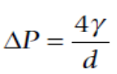
where ΔP is the difference in pressure between the interior of a liquid droplet and its outside environment, γ is the surface energy, and d is the diameter of the droplet. In Vo = a³. Thus
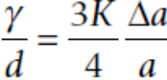
Since the surface energy increases as the particle size decreases, because the radius of curvature decreases, last equation reveals that the lattice parameter is reduced for a decrease in particle size.
Strain Confinement
Planar defects, such as dislocations are also affected when present in a nanoparticle. Dislocations play a crucial role in plastic deformation, thereby controlling the behavior of materials when subjected to a stress above the yield stress. In the case of an infinite crystal, the strain energy of a perfect edge dislocation loop is given by
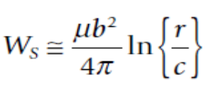
where μ is the shear modulus, b is the Burgers vector, r is the radius of the dislocation stress field, and c is the core cutoff parameter.
In the nanoscale regime, it is vital to take into account the effect posed by the nearby free surfaces. In other words, there are image forces acting on the dislocation half-loop. As a consequence, the strain energy of a perfect edge dislocation loop contained in a nanoparticle of size R is given by
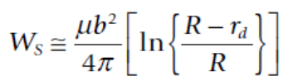
Where r_{d} is the distance between the dislocation line and the surface of the particle and the other symbols have the same meaning as before.
- A comparison of Equations reveals that for small particle sizes, the stress field of the dislocations is reduced.
- In addition, the presence of the nearby surfaces will impose a force on the dislocations, causing dislocation ejection toward the nanoparticle’s surface.
- The direct consequence of this behavior is that nanoparticles below a critical size are self-healing as defects generated by any particular process are unstable and ejected.

Quantum Effects
In bulk crystalline materials, the atomic energy levels spread out into energy bands. The valence band, which is filled with electrons, might or might not be separated from an empty conduction band by an energy gap.
For conductor materials such as metals, there is typically no band gap. Therefore, very little energy is required to bring electrons from the valence band to the conduction band, where electrons are free to flow.
For insulator materials such as ceramics, the energy band gap is quite significant, and thus transferring electrons from the valence band to the conduction band is difficult.
In the case of semiconductor materials such as silicon, the band gap is not as wide, and thus it is possible to excite the electrons from the valence band to the conduction band with some amount of energy.
This overall behavior of bulk crystalline materials changes when the dimensions are reduced to the nanoscale.
For 0-D nanomaterials,where all the dimensions are at the nanoscale, an electron is confined
in 3-D space. Therefore, no electron delocalization (freedom to move) occurs.
For 1-D nanomaterials, electron confinementoccurs in 2-D, whereas delocalization takes place along the longaxis of the nanowire/rod/tube.
For 2-D nanomaterials,the electrons will be confined across the thickness but delocalized in the plane of the sheet.
For 3-D nanomaterials, the electrons are fully delocalized in all dimensions.

Therefore, for 0-D nanomaterials the electrons are fully confined. On the other hand, for 3-D nanomaterials the electrons are fullydelocalized. In 1-D and 2-D nanomaterials, electron confinement and delocalization coexist.
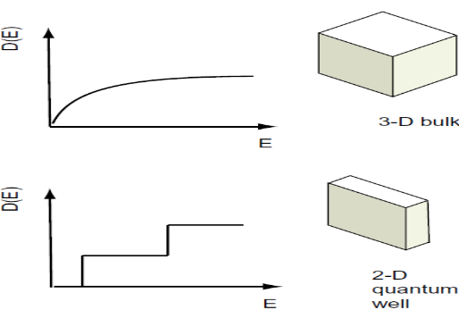 | 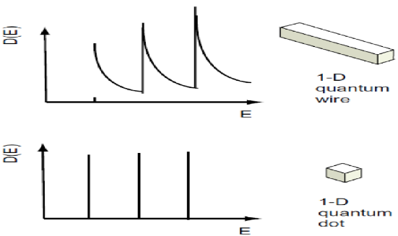
 | 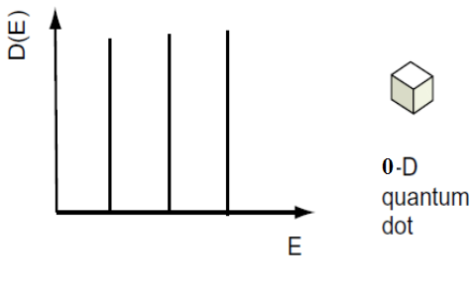

Under these conditions of confinement, the conduction band suffers profound alterations. The effect of confinement on the resulting energy states can be calculated by quantum mechanics, as the “particle in the box” problem. In this treatment, an electron is considered to exist inside of an infinitely deep potential well (region of negative energies), from which it cannot escape and is confined by the dimensions of the nanostructure. In 0-D, 1-D, and 2-D, the effects of confinement on the energy state can be written respectively as

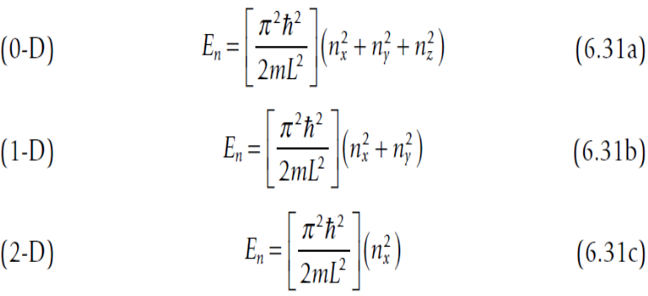
where ħ = h/2π, h is Planck’s constant, m is the mass of the electron, L is the width (confinement) of the infinitely deep potential well, and n_{x}, n_{y}, and n_{z} are the principal quantum numbers in the three dimensions x, y, and z. The smaller the dimensions of the nanostructure (smaller L), the wider is the separation between the energy levels, leading to a spectrum of discrete energies. In this fashion, the band gap of a material can be shifted toward higher energies by spatially confining the electronic carriers.

Another important feature of an energy state E_{n} is the number of conduction electrons, N (En), that exist in a particular state. As E_{n} is dependent on the dimensionality of the system, so is the number of conduction electrons. This also means that the number of electrons dN within a narrow energy range dE, which represent the density of states D (E), i.e., D (E) = dN/dE, is also strongly dependent on the dimensionality of the structure.
Therefore the density of states as a function of the energy E for conduction electrons will be very different for a quantum dot (confinement in three dimensions), quantum wire (confinement in two dimensions and delocalization in one dimension), quantum well (confinement in one dimension and delocalization in one dimension), and bulk material (delocalization in three dimensions.
Because the density of states determines various properties, the use of nanostructures provides the possibility for tuning these properties. For example, photoemission spectroscopy, specific heat, the thermo power effect, excitons in semiconductors, and the superconducting energy gap are all influenced by the density of states. Overall, the ability to control the density of states is crucial for applications such as infrared detectors, lasers, superconductors, single-photon sources, biological tagging, optical memories, and photonic structures.

Lecture # 11 &12
Date: 02/04/2020
Course: Nanotechnology & Nanostructures
Instructor: Dr. Zohra Kayani
Book: Introduction to Nanotechnology by Charles
Chapter: Properties of Individual NanoParticles

Properties of Nanomaterials:
- Mechanical Properties
Mechanical properties of solids depend on the microstructure, i.e. the chemical composition, the arrangement of the atoms (the atomic structure) and the size of a solid in one, two or three dimensions.
- Grain size effect and Young’s Modulus:
The intrinsic elastic modulus (bond strength) of a nanostructured material is essentially the same as that of the bulk material having micrometer-sized grains unless the grain size becomes very small, less than 5 nm.
Young's modulus is the factor relating stress and strain. It is the slope of the stress-strain curve in the linear region. The larger the value of Young's modulus, the less will be elastic the material.
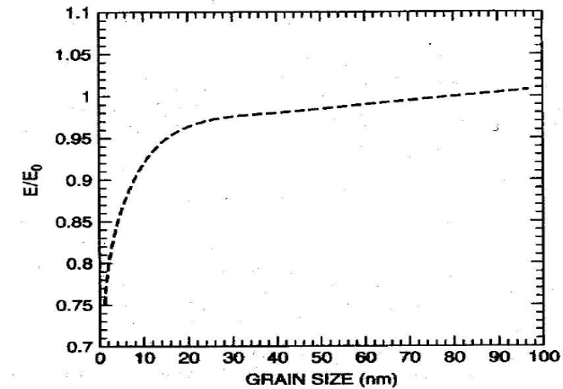
Figure is a plot of the ratio of Young's modulus E in nano-grained iron, to its value in conventional grain-sized iron E_{O} as a function of grain size. Below 20mn, Young's modulus begins to decrease from its value in conventional grain-sized materials.
- Grain size effect and Hall-Petch relation:
The Hall-Petch relation predicts behavior accurately in metals with ordinary grain sizes (i.e. Few micrometers to few hundred micrometers). Metals typically follow the Hall-Petch relation when
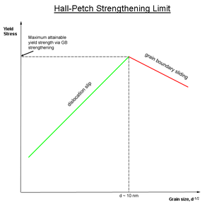
the average grain size is 100nm or larger, But Hall-Petch behaviour breaks down at smaller grain sizes. Indeed, an “Inverse Hall-Petch relationship” appears to exist at very small grain sizes, with yield strength actually decreasing as the grain size decreases.
The yield strength σ_{y} of a conventional grain-sized material is related to the grain size by the Hall-Petch equation:
Where σ_{o} is the frictional stress opposing dislocation movement, k is a constant, and d is the grain size in micrometers.
Hardness can also be described by a similar equation and the hardness H is just three times the strength σ.
- Mechanical Properties of Carbon Nanotubes:
The carbon nanotube (CNT) is a rolled-up sheet of graphene and has three types depending upon the rolling direction such as armchair, zigzag and chiral.
The Young's modulus of steel is about 30,000 times that of rubber. Carbon nanotubes have Young's moduli ranging from 1.28 to 1.8TPa (1TPa = 10⁷Pa). Young's modulus of steel is 0.21 T Pa, which means that Young's modulus of carbon nanotubes is almost 10 times that of steel. This would imply that carbon nanotubes are very stiff and hard to bend.
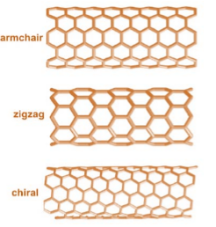
However, this is not quite true because they are so thin. When carbon nanotubes are bent, they are very resilient. They buckle like straws but do not break, and can be straightened back without any damage.
The reason behind that is bond nature between the carbon atoms. The electronic structure of carbon is 1s² 2s² 2p² and when carbon atoms combine to form graphite, sp2 hybridization will occurs. In this process, one s-orbital and two p-orbitals combine to form three hybrid sp² -orbitals at 120° to each other within a plane. This in-plane bond is referred to as σ-bond (sigma–bond). This is a strong covalent bond that binds the atoms in the plane, and results in the high stiffness and high strength of a CNT. The remaining p-orbital is perpendicular to the plane of the σ-bonds. It contributes mainly to the interlayer interaction and is called the Π-bond (pi–bond). These out-of planes, delocalized Π-bonds interact with the Π-bonds on the neighbouring layer. This interlayer interaction of atom pairs on neighbouring layers is much weaker than a sigma bond. Also Unlike bulk materials, the density of the defects in nanotubes is presumably less and therefore the strength is presumably signiﬁcantly higher at the nanoscale.
Therefore Young's modulus is a measure of how stiff or flexible a material is. And Tensile strength is a measure of the amount of stress needed to pull a material apart. The tensile strength of carbon nanotubes is about 45 billion pascals. High-strength steel alloys break at about 2 billion pascals. Thus carbon nanotubes are about 20 times stronger than steel.
- Electrical Properties
In metallic state, conductivity of nanotubes is very high. These can carry upto million Ampere per cm².
Copper wire fails to carry such a large amount of current because of the resistive heating, the copper wire melts. Carbon nanotubes have the most interesting property that they are metallic or semiconducting depending on the diameter and chirality of the tube. Chirality refer to how the tubes are rolled. Synthesis generally results in a mixture of tubes two third of which are semiconducting and one-third metallic.
The electronic states of the Nanotubes do not form a single wide electronic energy band but instead split into one-dimensional sub-bands. These states can be modeled by a potential well having a depth equal to the length of the nanotube.
Electron transport has been measured on individual single-walled carbon nanotubes. The measurements at a milli kelvin (T=0.001 K) on a single metallic nanotube lying across two metal electrodes show step like features in the current voltage measurements as shown in figure.
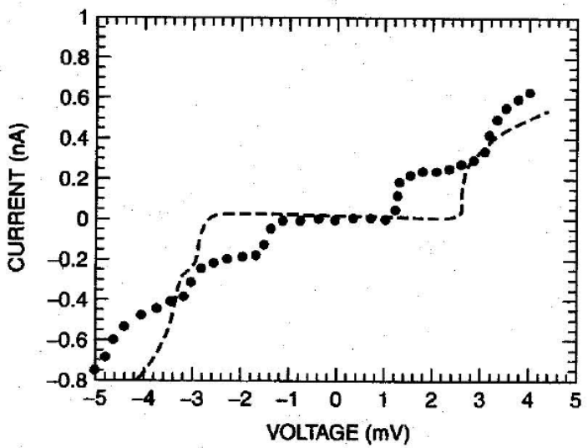
The steps occur at voltages which depend on the voltage applied to a third electrode that is electrostatically coupled to the nanotube. This resembles a field effect transistor made from a carbon nanotube. The step like features in the curve are due to single-electron tunneling and resonant tunneling through single molecular orbitals. Single electron tunneling is a quantum mechanical effect in which an electron can penetrate a potential barrier higher than the kinetic energy of the electron.
- Optical Properties
Because of their role in quantum dots, nanoparticles made of the elements, which are normal constituents of semiconductors.
The most striking property of nanoparticles made of semiconducting elements is the pronounced changes in their optical properties compared to those of the bulk material. There is a significant shift in the optical absorption spectra toward the blue (shorter wavelength) as the particle size is reduced.
In a bulk semiconductor a bound electron-hole pair can be produced by a photon having energy greater than that of the band gap of the material. Because of the coulomb attraction between the positive hole and the negative electron, the bound pair, called an exciton is formed that can move through the lattice. The separation between the hole and the electron is many lattice parameters. The existence of the exciton has a strong influence on the electronic properties of the semiconductor and its optical absorption. The exciton can be modeled as a hydrogen-like atom.
When the size of the nanoparticle becomes smaller than or comparable to the radius of the orbit of the electron-hole pair, there arise two situations:
- the weak-confinement
- and the strong-confinement regimes.
In the weak regime, the particle radius is larger than the radius of the electron-hole pair, but the range of motion of the exciton is limited which causes a blue shift of the absorption spectrum. When the particle radius is smaller than the radius of the electron-hole pair, the motion of the electron and the hole become independent, and the exciton does not exist. The hole and the electron have their own set of energy levels. Here there is also a blue shift, and the emergence of a new set of absorption lines.
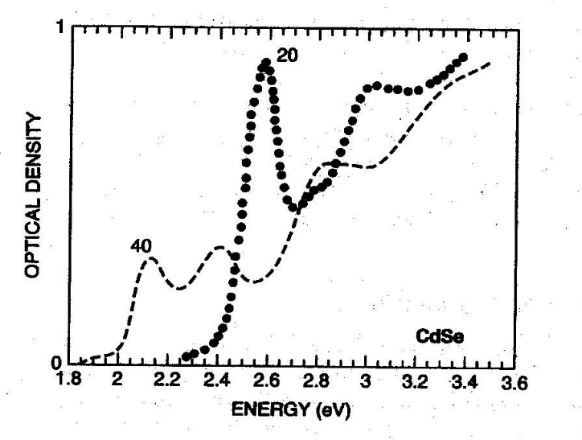
Figure shows the optical absorption spectra of a CdSe nanoparticle at two different sizes measured at 10K. The lowest energy absorption region (the absorption edge) is shifted to higher energy as the particle size decreases. Since the absorption edge is due to the band gap, this means that the band gap increases as particle size decreases. The intensity of the absorption increases as the particle size is reduced. The higher energy peaks are associated with the exciton and they shift to higher energies with the decrease in particle size. These effects are a result of the confinement of the exciton. Essentially, as the particle size is reduced, the hole and the electron are forced closer together and the separation between the energy levels changes.
- Magnetic Properties:
Magnetic nanoparticle carriers consist of three functional parts:
- a magnetic core
- a surface coating
- a functionalized outer coating
At the center of the carrier is the superparamagnetic core which allows for the magnetic manipulation of the particle in the presence of an external magnetic field. The composition of the magnetic core is dependent on the application. For example, magnetite (Fe₃O₄) and maghemite (γ-Fe₂O₃) with high oxidative stability are currently the only accepted nontoxic magnetic materials for medical applications.
Magnetic cores consisting of materials such as cobalt, nickel, and neodymium-iron-boron may offer improved magnetic properties and however, these materials may be susceptible to oxidation or be toxic for use in the human body.
By virtue of their smaller size, magnetic nanoparticles are able to overcome the influence of the gravitational field, magnetic field gradient, and the potential magnetic agglomeration which could result when particles come into contact with one another.
Particles may be attracted to one another as a result of London-type van der Waals attractive forces. In order to minimize such interactions of the particle with the system environment, to ensure stability, and to prevent agglomeration, a surface coating may be required to provide steric repulsion. The functionalized outer coating may be a component such as a molecule or a ligand for scavenging of metal ions.
Ferromagnetic materials are subdivided into areas known as domains. In an unmagnetized sample, the moments of these domains are randomly orientated, but tend to align themselves in the direction of an external applied magnetic field. As the particle size approaches a certain minimum critical size, often in the nanoscale range, the formation of domain walls becomes energetically unfavorable. Changes in magnetization occur through the rotation of spins rather than through the motion of domain walls. Particles exhibiting these properties are called single domain. As particle size is decreased further, spins are affected by thermal fluctuations and the particles become superparamagnetic. This superparamagnetic property of materials is useful in that individual particles become magnetized only when exposed to an external magnetic field, but exhibit no remanent magnetization when the field is removed. In addition, the particle size provides a large surface area for functionalization which lends itself to applications of small dimensions of interest.
Other Properties
While the emphasis of the previous discussion bas been on the effect of nanosized microstructure on mechanical and electrical properties, many other properties of bulk nanostructured materials are also affected.
- The magnetic behavior of bulk ferromagnetic material made of nanosized grains is quite different from the same material made with conventional grain sizes.
- The inherent chemical reactivity of nanoparticles depends on the number of atoms in the cluster. It might be expected that such behavior would also be manifested in bulk materials made of nanostructured grains providing a possible way to protect against corrosion and the detrimental effects of oxidation, such as the formation of the black silver oxide coating on silver.
- The melting temperature of nanostructured materials is also affected by grain size. Melting temperature of nanostructured materials decreases with the decrease in grain size. It has been shown that indium containing 4 nm nanoparticles has its melting temperature lowered by 110K.
- In the superconducting phase, there is a maximum current that a material can carry and the maximum value is called the critical current. When the current exceeds that value, the superconducting state is removed and the material returns to its normal resistance.
- The optical absorption properties of nanoparticles determined by transitions to excited states, depend on their size and structure. In principle, it should therefore be possible to engineer the optical properties of bulk nanostructured materials.
- The mechanical, electrical, thermal, optical and catalytic properties of nanocomposites depend upon the component materials.

